Insert your centre number, name and candidate number into the header above.
Save this evidence document as evidence_ followed by your centre number_ candidate number. For example: evidence_ zz999_9999
Screenshots or program listings must be copied into appropriate cells in the following table.
Examiners must be able to read the contents including any screenshots without the use of a magnifying glass. Answers that are not readable or missing will not be awarded any marks.
Save this evidence document at regular intervals, for example every 10 minutes.
Question 1
Part 1(a)
{Copy and paste the program code listing for question 1(a) here}

# players array[0:11] string
# scores array[0:11] integer
players = []
scores = []

Part 1(b)
{Copy and paste the program code listing for question 1(b) here}

def ReadHighScores():
try:
file = open("HighScore.txt", 'r')
index = 0
for item in file:
if index % 2 == 1:
scores.append(item)
else:
players.append(item)
index = index + 1
file.close()
except IOError:
print("File is not found")

Part 1(c)
{Copy and paste the program code listing for question 1(c) here}

def OutputHighScores():
for count in range(10):
print(players[count], scores[count])

Part 1(d)(i)
{Copy and paste the program code listing for question 1(d)(i) here}

def main():
global players, scores
ReadHighScores()
OutputHighScores()

Part 1(d)(ii)
{Copy and paste the screenshot for question 1(d)(ii) here}

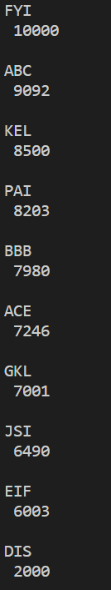

Part 1(e)(i)
{Copy and paste the program code listing for question 1(e)(i) here}

def main():
global players, scores
ReadHighScores()
OutputHighScores()
PlayerName = ""
PlayerScore = 0
while len(PlayerName) != 3:
PlayerName = str(input("Enter a 3-character player name"))
while PlayerScore < 1 or PlayerScore > 100000:
PlayerScore = int(input("Enter player's score between 1 and 100000"))
players, scores = UpdateHighScores(PlayerName, PlayerScore)

Part 1(e)(ii)
{Copy and paste the program code listing for question 1(e)(ii) here}

def UpdateHighScores(NewPlayer, NewScore):
global players, scores
if NewScore > scores[9]:
index = 0
written = False
while written == False:
if NewScore > scores[index]:
lim = 9
while lim > index:
scores[lim] = scores[lim - 1]
players[lim] = players[lim - 1]
lim = lim - 1
scores[lim] = NewScore
players[lim] = NewPlayer + "\n"
written = True
index = index + 1
return players, scores

Part 1(e)(iii)
{Copy and paste the program code listing for question 1(e)(iii) here}

players, scores = UpdateHighScores(str(PlayerName), int(PlayerScore))
OutputHighScores()

Part 1(e)(iv)
{Copy and paste the screenshot for question 1(e)(iv) here}

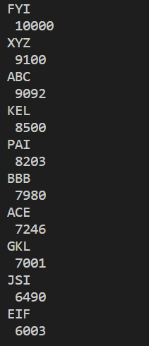

Part 1(f)
{Copy and paste the program code listing for question 1(f) here}

def WriteTopTen():
global players, scores
newfile = open("NewHighScore.txt", 'w')
index = 0
while index < 10:
newfile.write(players[index])
newfile.write(str(scores[index]) + "\n")
index = index + 1

Question 2
Part 2(a)
{Copy and paste the program code listing for question 2(a) here}

class Balloon():
# self.__defenceItem string
# self.__colour string
# self.__health integer
def __init__(self, DefenceItemP, ColourP):
self.__defenceItem = DefenceItemP
self.__colour = ColourP
self.__health = 0

Part 2(b)
{Copy and paste the program code listing for question 2(b) here}

def GetDefenceItem(self):
return self.__defenceItem

Part 2(c)
{Copy and paste the program code listing for question 2(c) here}

def ChangeHealth(self, change):
self.__health = self.__health + change
return self.__health

Part 2(d)
{Copy and paste the program code listing for question 2(d) here}

def CheckHealth(self):
if self.__health < 0:
return True
else:
return False

Part 2(e)
{Copy and paste the program code listing for question 2(e) here}

def main():
defenceItem1 = str(input("Enter your defence item: "))
colour1 = str(input("Enter the colour of your balloon: "))
balloon1 = Balloon(defenceItem1, colour1)

Part 2(f)
{Copy and paste the program code listing for question 2(f) here}

def Defend(object):
OppStrength = int(input("Enter the strength of the opponent: "))
object.ChangeHealth(OppStrength * -1)
print(object.GetDefenceItem())
if object.CheckHealth == True:
print("balloon has health remaining")
else:
print("balloon has no health remaining")
return object

Part 2(g)(i)
{Copy and paste the program code listing for question 2(g)(i) here}

balloon1 = Defend(balloon1)

Part 2(g)(ii)
{Copy and paste the screenshot for question 2(g)(ii) here}

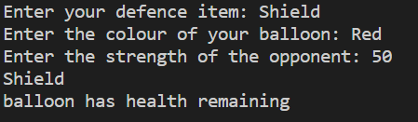

Question 3
Part 3(a)
{Copy and paste the program code listing for question 3(a) here}

# queue array[0:10] integer
# head integer
# tail integer
# num integer
queue = [0 for i in range(10)]
head = 0
tail = 0
num = 0

Part 3(b)
{Copy and paste the program code listing for question 3(b) here}

def enqueue(queue, head, tail, num, data):
if num == 10:
return False, queue, head, tail, num
queue[tail] = data
if tail >= 9:
tail = 0
else:
tail = tail + 1
num = num + 1
return True, queue, head, tail, num

Part 3(c)
{Copy and paste the program code listing for question 3(c) here}

def dequeue(queue, head, tail, num):
if num == 0:
return False, queue, head, tail, num
data = queue[head]
if head >= 9:
head = 0
else:
head = head + 1
num = num - 1
return data, queue, head, tail, num

Part 3(d)(i)
{Copy and paste the program code listing for question 3(d)(i) here}

def main():
global queue, head, tail, num
for index in range(11):
data = input("enter input data: ")
result, queue, head, tail, num = enqueue(queue, head, tail, num, data)
if result == True:
print("item was added")
else:
print("item was not added")
result2, queue, head, tail, num = dequeue(queue, head, tail, num)
print(result2)
result3, queue, head, tail, num = dequeue(queue, head, tail, num)
print(result3)

Part 3(d)(ii)
{Copy and paste the screenshot for question 3(d)(ii) here}

